IOT EMBEDDED FIRMWARE- ASSIGNMENT 1

**Q1) How much current does a single LED draw when the output drive is set to “Strong” with the original code?**

* Peak current when a single LED is ON = 5.10mA.
* The current consumed by the board = 4.59mA.
* Current drawn by the led = 0.51mA.

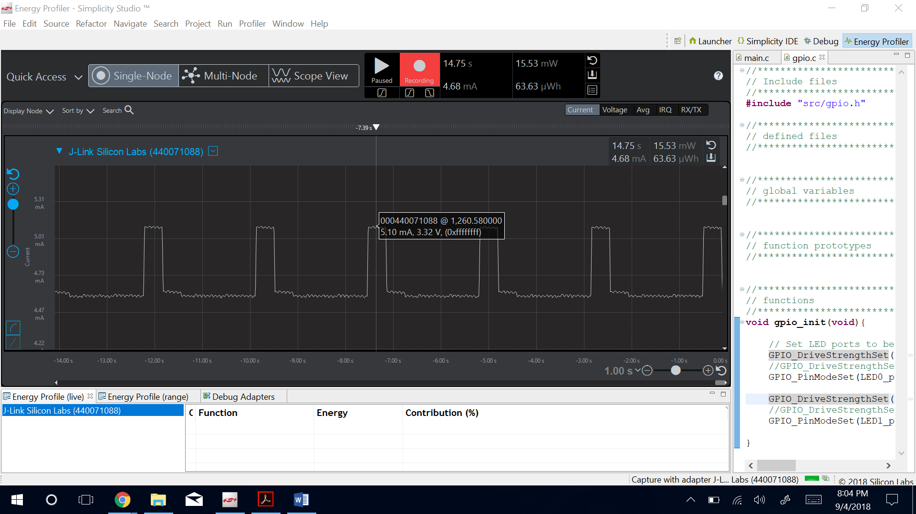

Figure 1: Image for Question 1

__________________________________________________________________________________________________

**Q2) After commenting out the standard output drive and uncommenting “Weak” drive, how much current does a single LED draw?**

Ans. In Weak Drive

* Peak current when a single LED is ON = 4.94
* The current consumed by the board = 4.38mA.
* Current drawn by the led = 0.56mA.

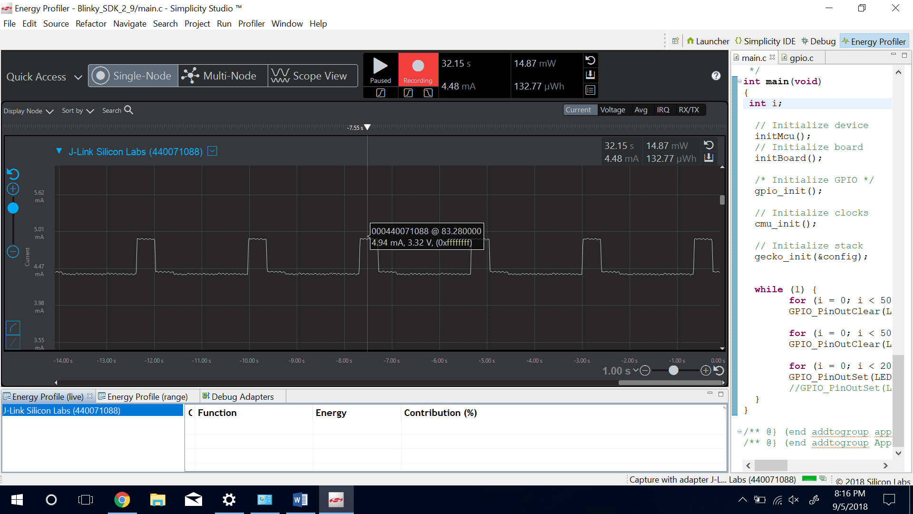

Figure 2: Image for Question 2

**Q3) Is there a difference in current between the answers for question 1 and 2? And, explain your answer, why or why not?**

Ans. There is no difference in current between the answers for question 1 and 2. In weak drive the maximum current the blue gecko can source is 3mA for IOVDD>3v. The led only consumes 0.56mA. Also, in strong mode the current source capability of the blue gecko is up to 20mA. As these maximum values are way above the current value drawn by the LED we can see same current consumption in weak and strong drive.

________________________________________________________________________________________________________________________

**Q4) Using the Energy Profiler with “weak” drive LEDs, what is the average current measured before commenting out turning on LED1?**

* Average current measured before commenting out turning on LED1**= 4.84mA.**

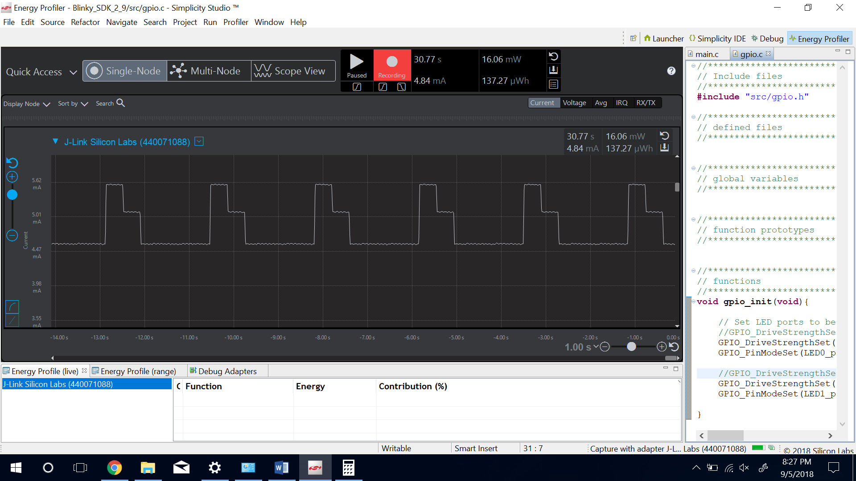

Figure 3: Image for Question 4

**Q5) Using the Energy Profiler with “weak” drive LEDs, what is the average current measured after commenting out turning on LED1?**

* Average current measured after commenting out turning on LED1= **4.48mA.**



Figure 4: Image for Question 5